The Songhai Bamboo Roots Youth Organization Present
Dancing Lavishly Studios

Dance Classes for All

Children and Adult Dance Session
(8 to 16 years) & (18+ Years)
Starting February, Fridays & Saturdays
At 515 S 2nd Street Suit B

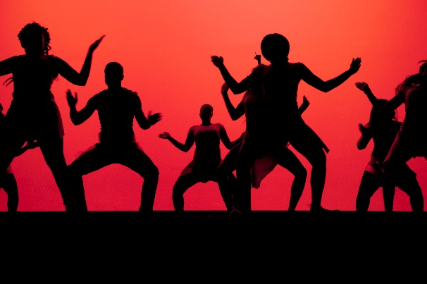
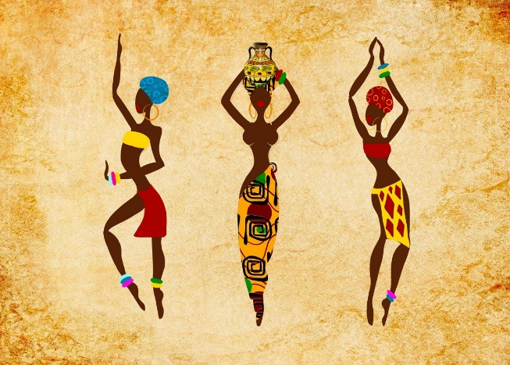

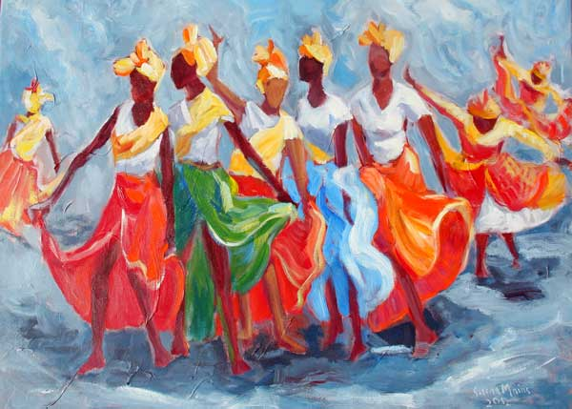
Modern
African

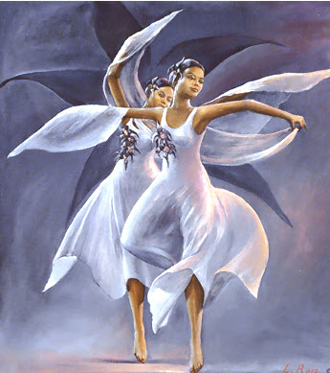
Bamboula Cultural
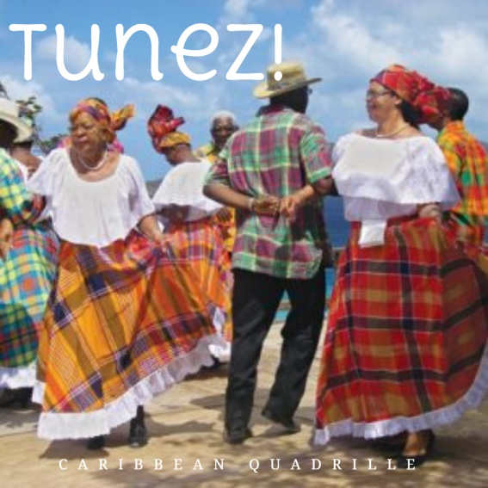
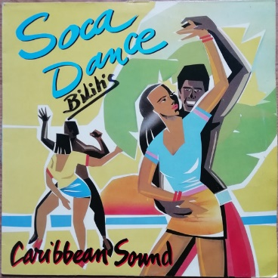

Spiritual
Caribbean Quadrille
Soca Dance

For more information please contact:
Mrs. Vee Lavishly at 254-418-5454 or
Ms. Darlene Golden at 254-681-8861
info@sbrca.org

